AWS EC2 CHALLENGES TASK

- Install nginx
- Install Nginx: The nginx package and its dependencies were installed using the sudo yum install nginx command.
- Initial Status Check: The service was confirmed to be installed but inactive (dead).
- Enable Service: Nginx was configured to start automatically on future boots (systemctl enable nginx).
- Start Service: The Nginx service was manually started (systemctl start nginx).
- Final Status Check: The service was confirmed to be active (running).

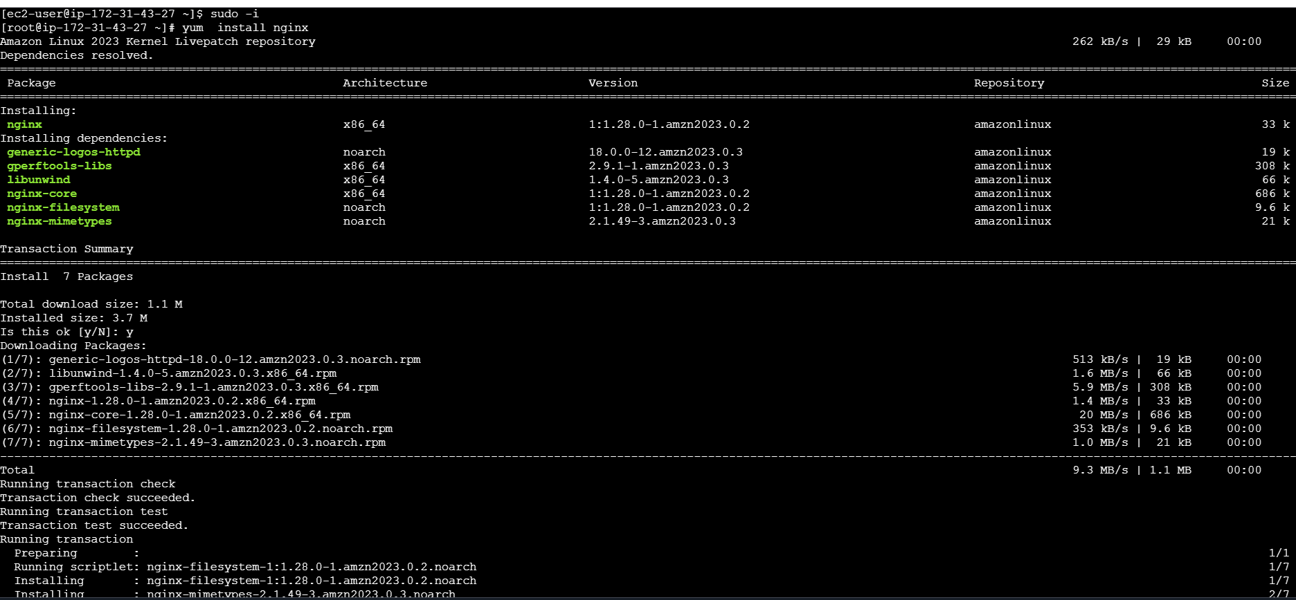

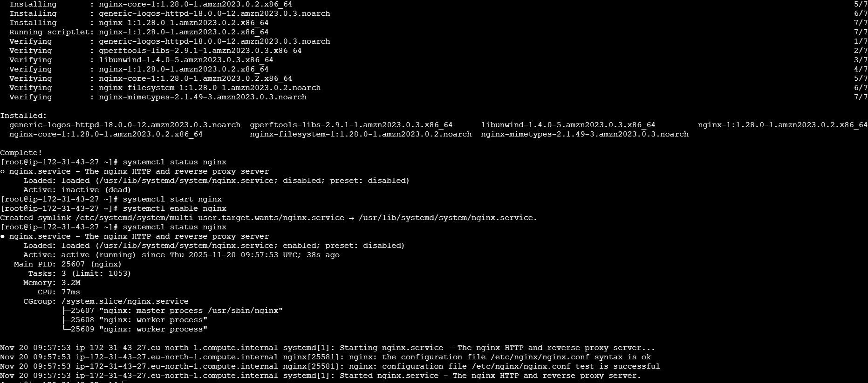

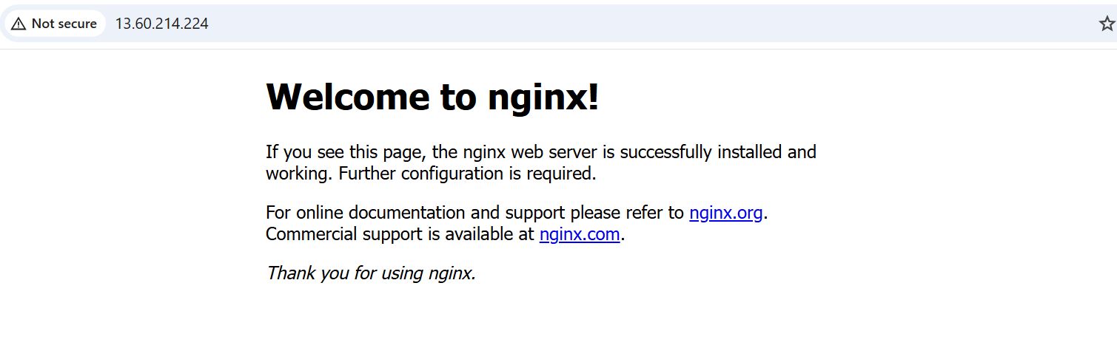

- Install docker

- Yum install docker

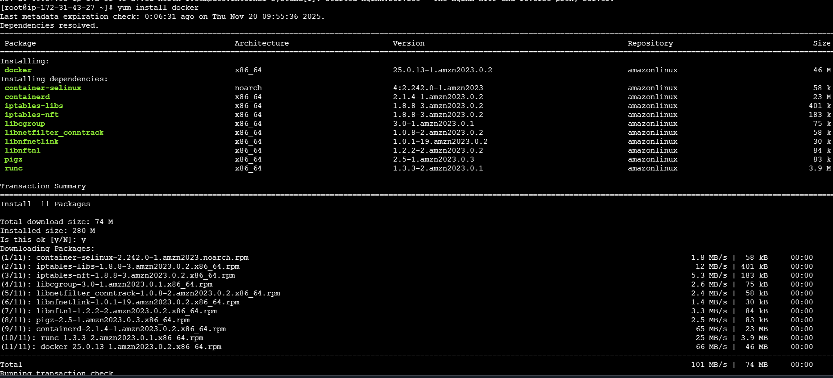
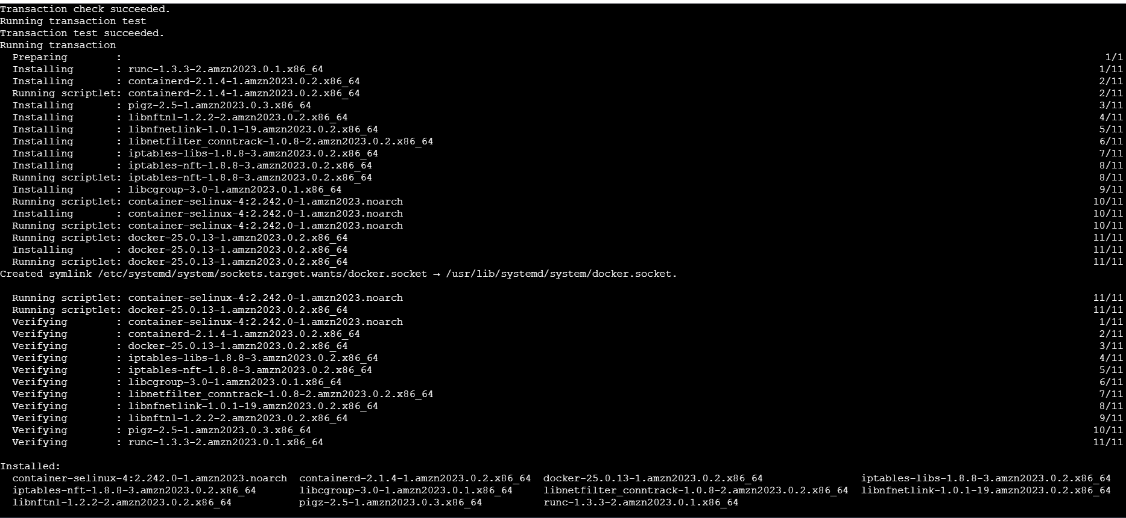

- Install apache

- install Apache (httpd): The httpd package and its dependencies were installed using the yum install httpd command.
- Initial Status Check: The service was confirmed to be installed but inactive (dead).
- View Configuration: The user displayed the main configuration file, /etc/httpd/conf/httpd.conf, to review default settings.
- Modify Configuration (Port Change): The user edited the configuration file (vi /etc/httpd/conf/httpd.conf) to change the Listen directive from the default port (likely 80) to port 8081 (Listen 8081).
- Restart/Stop/Start Service: The service was explicitly stopped, restarted, and then enabled.
- systemctl stop httpd
- systemctl restart httpd
- systemctl enable httpd (to ensure it starts on boot)
- Final Status Check: The service was confirmed to be active (running), and the log message verified that the server was successfully configured and listening on port 8081.

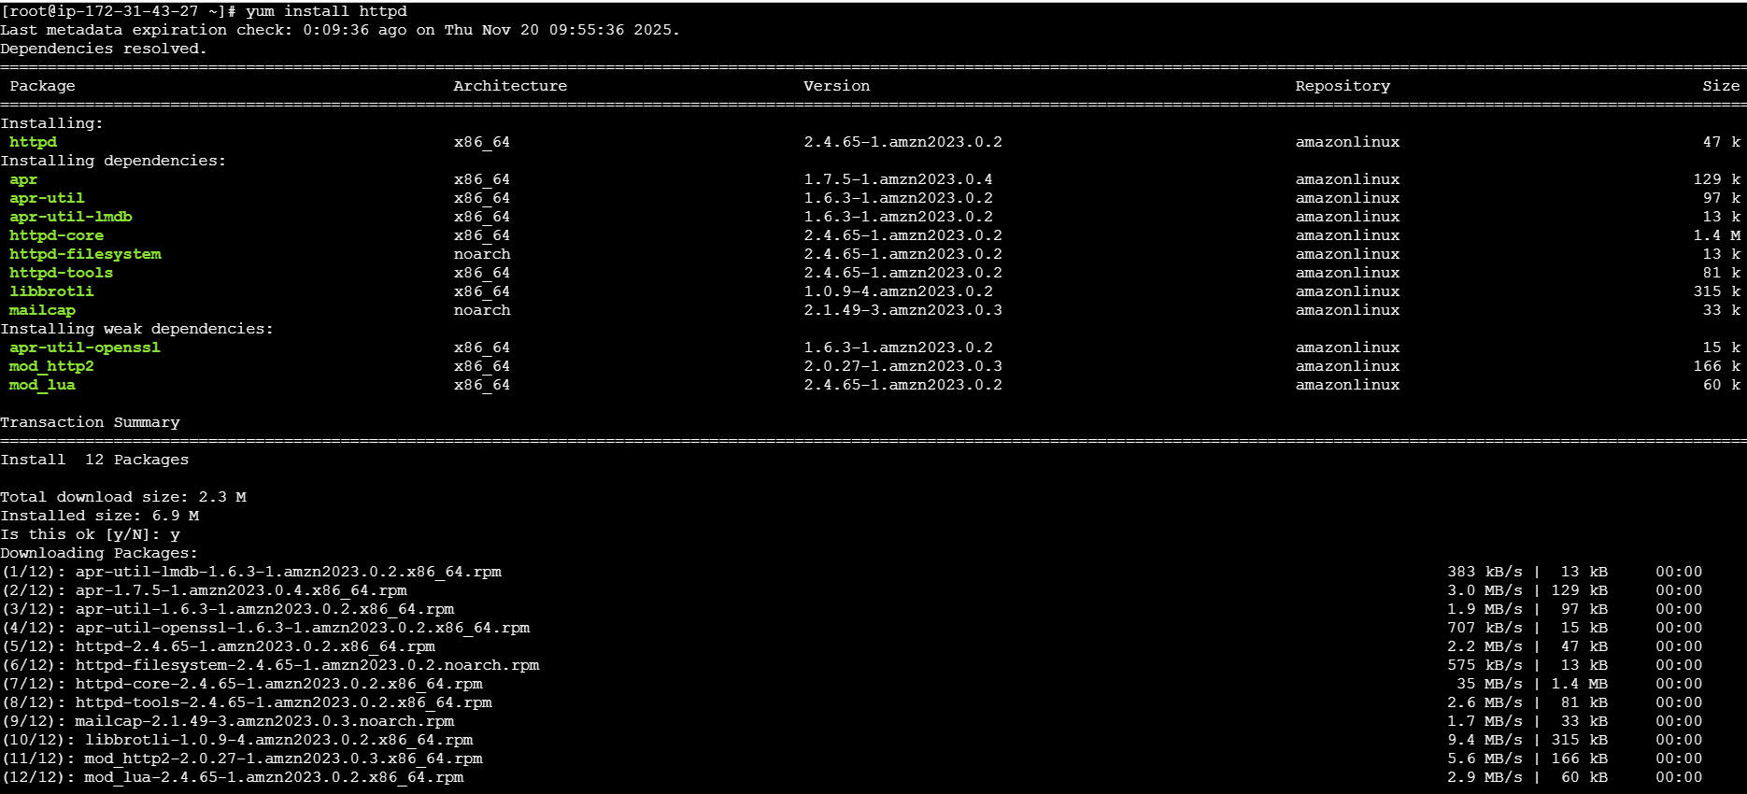

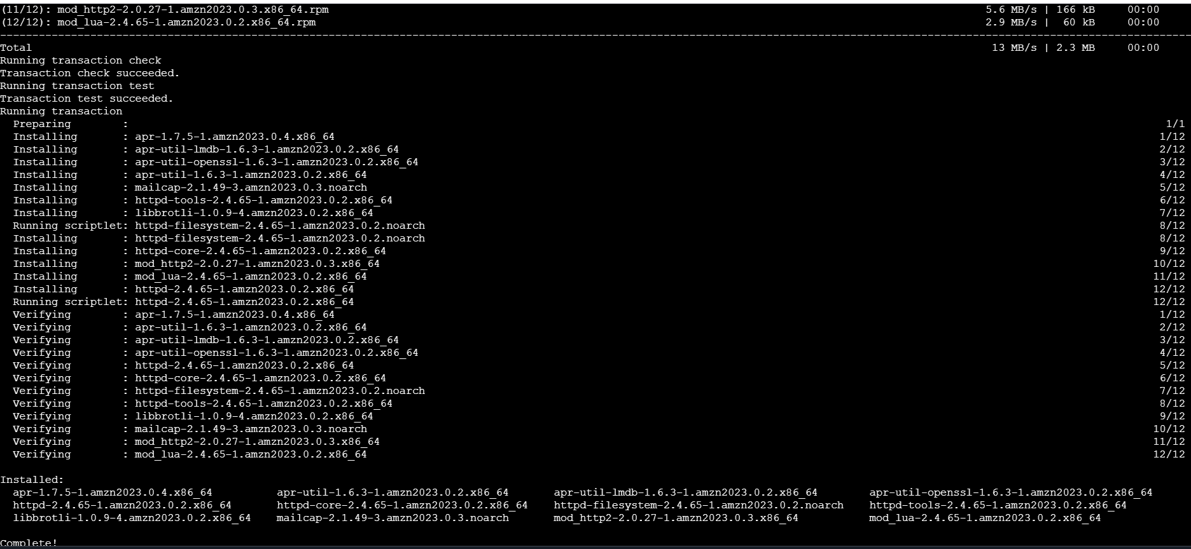

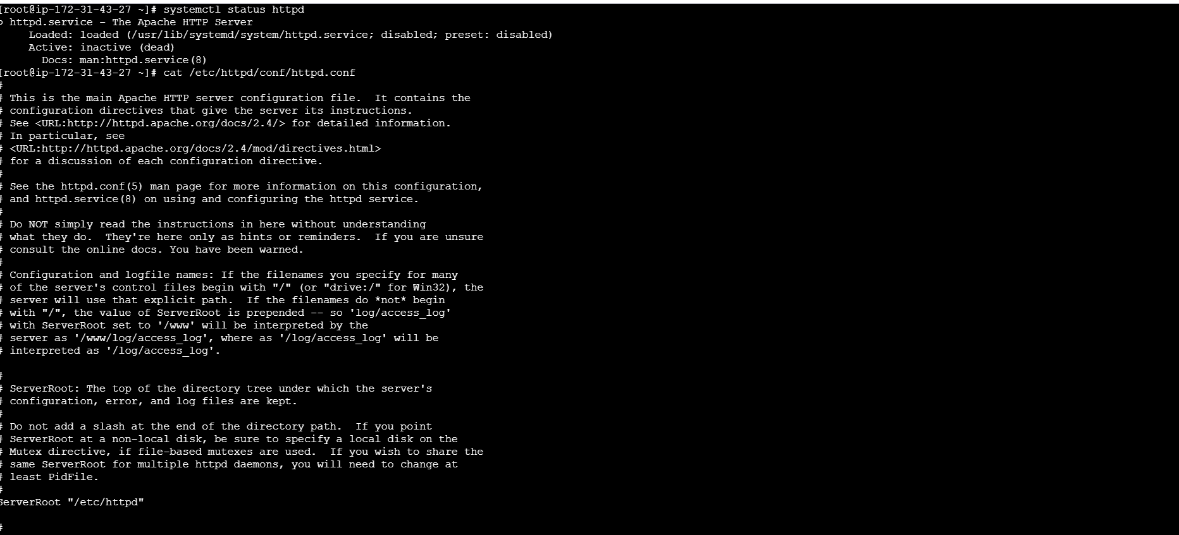
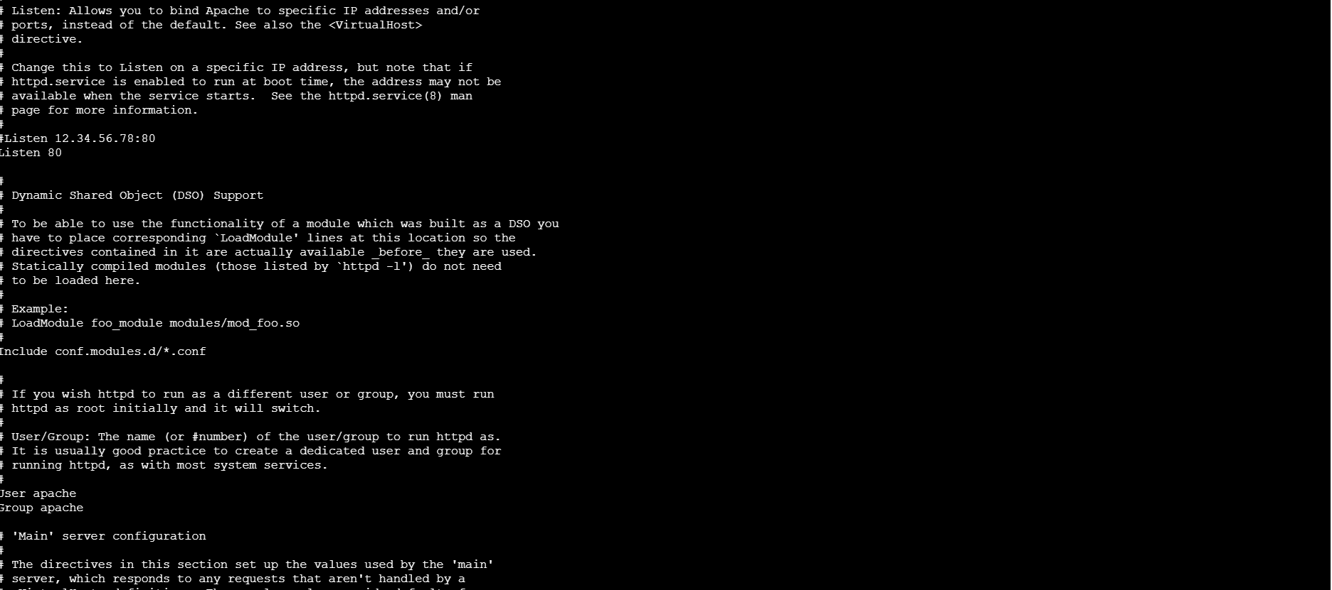

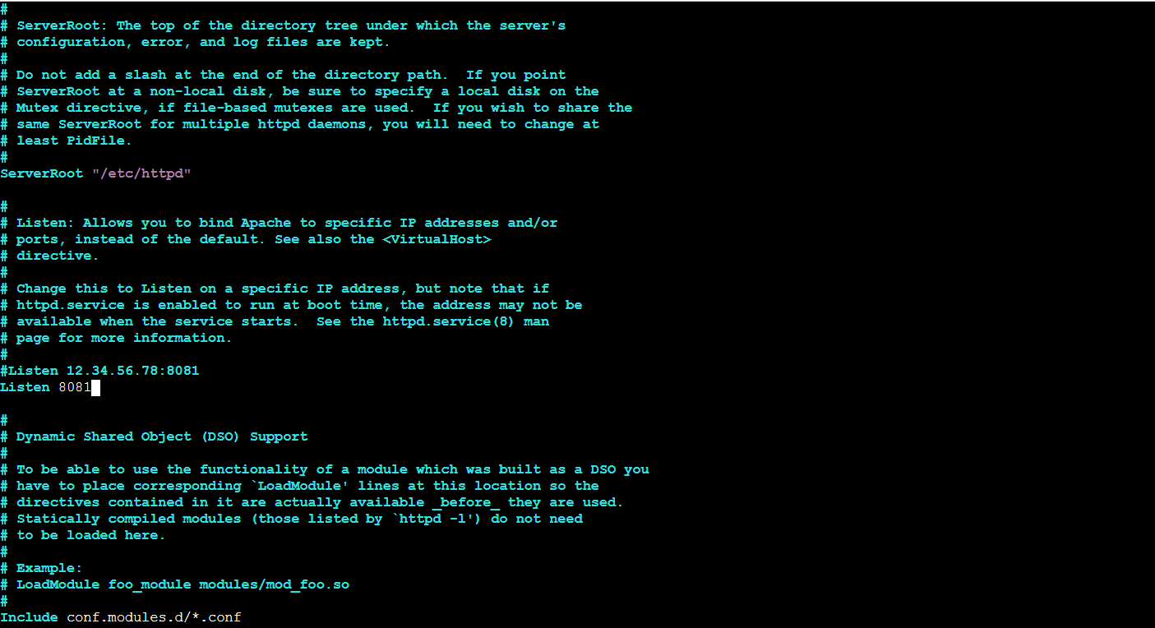

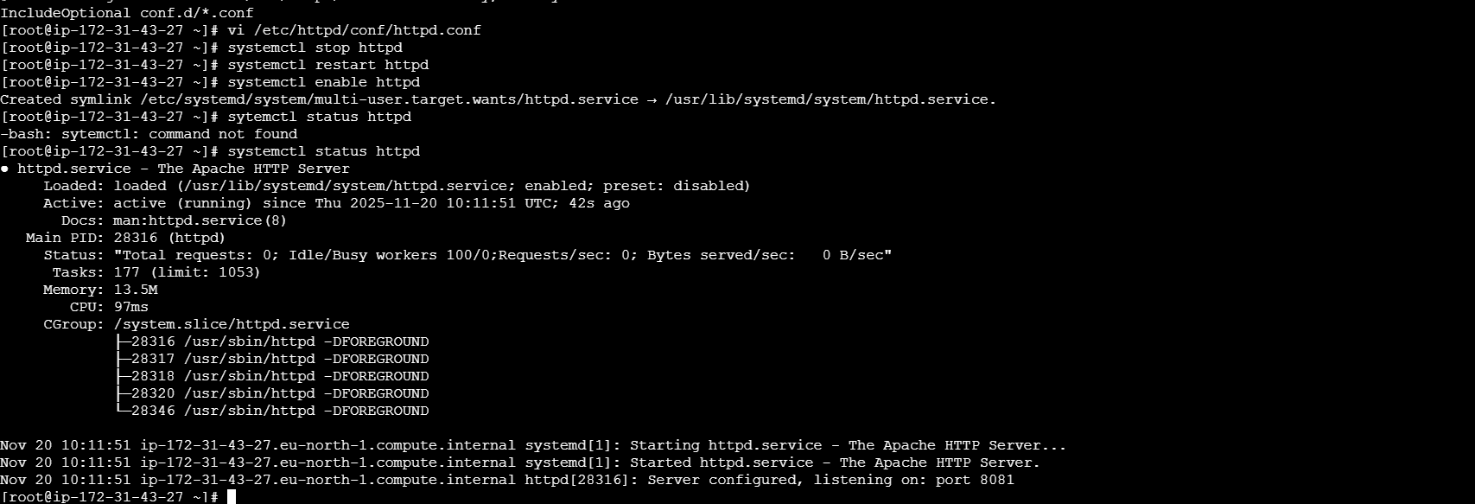
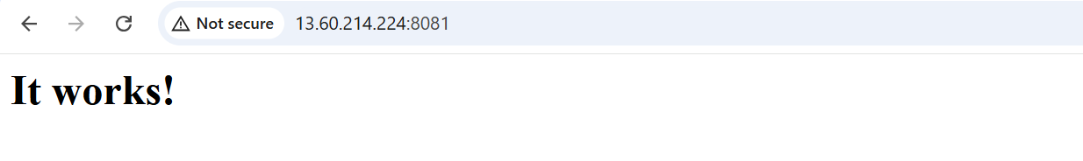

- Install apache tomcat
- Download Tomcat: The user downloaded the Apache Tomcat 9.0.112 compressed file (apache-tomcat-9.0.112.tar.gz) using the wget command.
- Extract Tomcat: The compressed file was extracted using tar xvf into a directory named apache-tomcat-9.0.112.
- Check Java (Initial): The user attempted to run java -version but the command was not found, indicating that Java was not installed.
- Install Java Dependency: The user installed Java 17 (Corretto), which is required to run Tomcat, using the command sudo dnf install java-17-amazon-corretto -y.
- Check Java (Final): After installation, the java -version command successfully confirmed that OpenJDK Runtime Environment 17.0.10 was installed.
- Start Tomcat: The user navigated to the Tomcat directory and executed the start-up script (./bin/startup.sh), which resulted in the message "Tomcat started.".

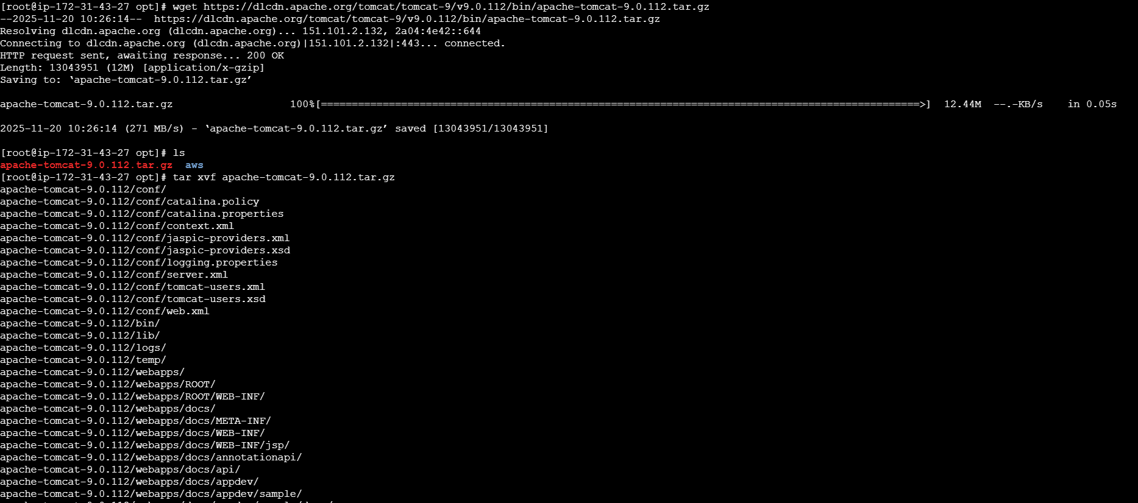

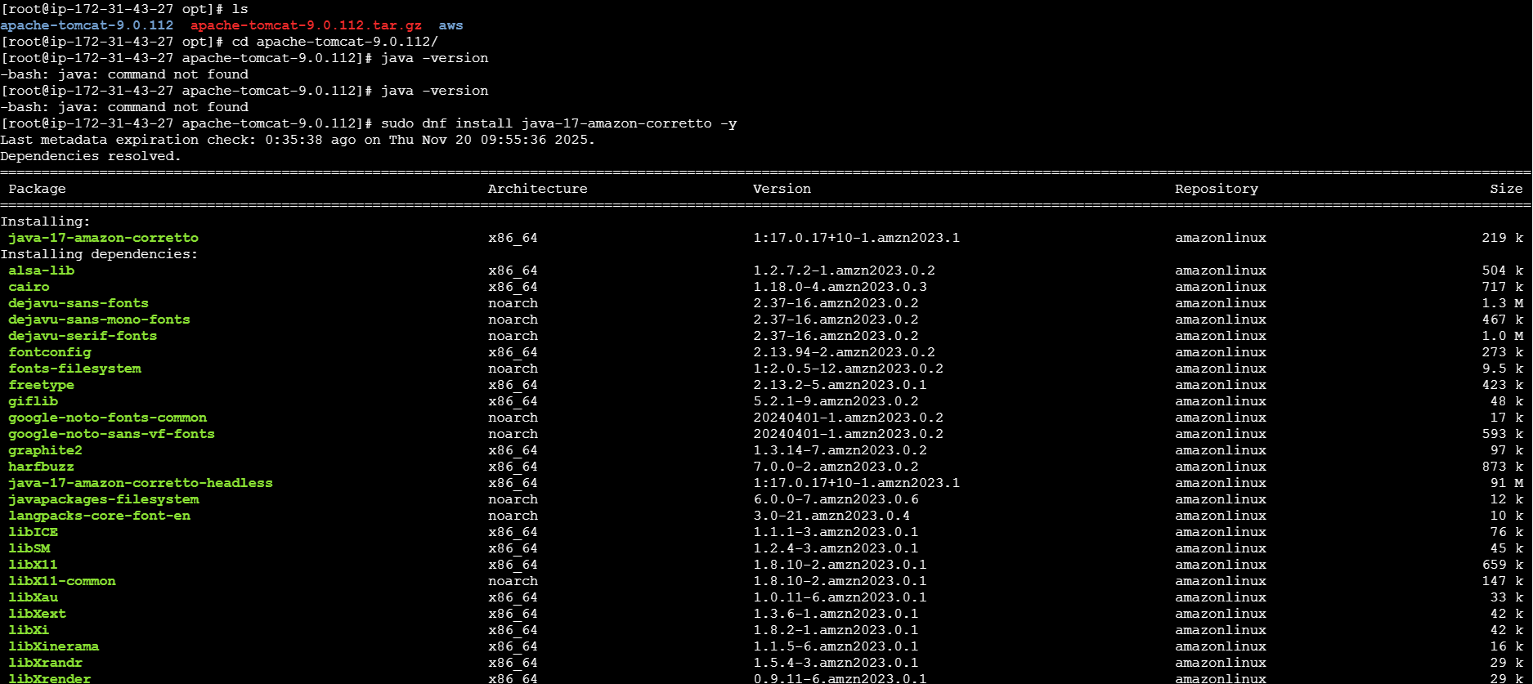

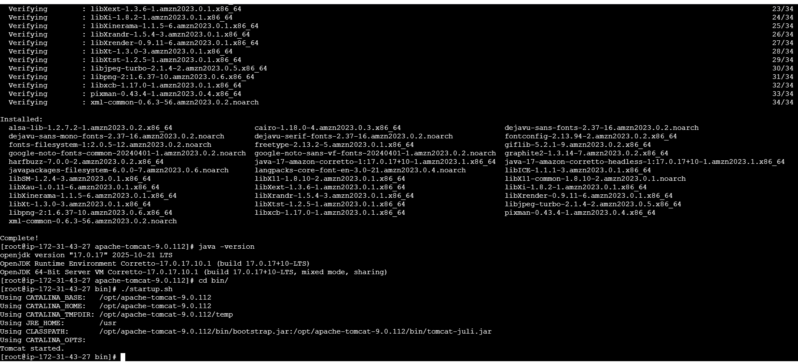

- Install jenkins

- Prerequisite to Install Jenkins is java.
- Download Jenkins Repo:

- sudo wget -O /etc/yum.repos.d/jenkins.repo https://pkg.jenkins.io/redhat-stable/jenkins.repo

- Import the Jenkins key:

- sudo rpm --import https://pkg.jenkins.io/redhat-stable/jenkins.io-2023.key
- Update ec2:

- sudo yum upgrade
- Add required dependencies for the jenkins package:

- sudo yum install java-17-amazon-corretto -y

- Install Jenkins:
- sudo yum install jenkins

- Set up Repository and Install Jenkins:
  - The user added the Jenkins repository file (jenkins.repo) using wget.
  - The corresponding public key was imported using rpm --import.
  - Jenkins version 2.528.2-1.1 was installed using sudo yum install jenkins.
- Initial Service Failure Troubleshooting:
  - The initial attempt to start the service (systemctl start jenkins) failed with an exit code error.
  - Reviewing the status and journal logs indicated the service failed repeatedly (Failed to start jenkins.service).
  - The system was configured to use Java 17 (Corretto) via update-alternatives, which resolved an underlying Java environment issue.
- Successful Service Start:
  - After resolving the Java configuration, the service was restarted (systemctl restart jenkins.service).
  - The status check confirmed Jenkins was active (running) and listening on its default port, 8080. (Note: The browser URL shows the public IP address on port 8083, which suggests a firewall or reverse proxy changed the port externally, but the logs show the internal service running).
- Retrieve Admin Password:
  - The initial administrator password was retrieved from the file /var/lib/jenkins/secrets/initialAdminPassword.
- Web Interface Setup:
  - The user accessed the Jenkins web interface (via http://<IP_ADDRESS>:8083).
  - The initial setup was completed by entering the retrieved password.
  - The user proceeded to the Customize Jenkins step and chose to Install suggested plugins.
  - After plugin installation, the final Welcome to Jenkins! dashboard was reached.

